Index
Content | Page number
Witness Statement | 2-
Exhibit 01
Exhibit 02
Exhibit 03
Exhibit 04 and 04a
Exhibit 05

In the County Court at Brentford

Claim Number: XXX
Between

XXX
(Claimant)

V

XXX
(Defendant)

WITNESS STATEMENT OF DEFENDANT
FOR COURT HEARING ON 09/11/2022

- I am Mr XXX of XXX and I am the defendant against whom this claim is made. The facts below are true to the best of my belief and my account has been prepared based on my own knowledge.
- In my statement I shall refer to exhibits within the evidence supplied with this statement, referring to page and reference numbers where appropriate. My defence is repeated and I will say as follows:

Sequence of events
- I was driving down Whitton High Street approaching the Lidl store on my left. I saw the sign which read "Lidl parking at rear." (Exhibit 01) and seeing the next left turning, turned into it.
- There was no sign to say this was a pay and display parking area at the road entrance (Exhibit 02).
- It was raining heavily and dark between the two buildings as I drove down the narrow way. As I entered a parking area two women were walking out of the area on the right-hand side of my car. At least one of these had a large umbrella which as I later found out, had covered a sign behind them on the wall. (Exhibit 03). This sign was edge-on in the direction of travel.
- I entered the car park and saw a mix of free and used spaces. One space to my right had a large van in the space. I chose one of the spaces to my left and parked up (Exhibit 05 left-hand side marked on the picture as 5a).
- I looked around for any parking signs to indicate this was a pay and display area but saw none. I ran into the store as it was still raining. I purchased a small number of items, left the store and returned to my car.
- I was shocked to see what looked like a parking ticket on the windscreen. I looked around and only then saw a sign on a wall, now face on which had been hidden by the lady’s umbrella. I walked around the car park a bit further and found a vending machine behind the van which had still been hidden from my view. (Exhibit 05).
- It was an unfortunate set of circumstances that meant I did not see any indication this was a paid parking area.

Comment on Claimants Witness Statement dated 5th July 2022
- On page 15 the Claimant includes an overhead picture of the site which has a yellow marker for an entrance board at the high street entrance. This does not in fact exist as can be seen in Exhibit 02 taken on January 29th 2020 showing the entrance in question. After receiving the claimant’s documents I revisited and verified this again on 25th August 2022.
- The placeholder in purple for a sign “have you paid and displayed” does exist but is edge-on in the direction of travel, high up on the wall on the opposite side to a driver. On a narrow road with pedestrians present and driving with due care and attention this is not a prominent sign as can be seen in Exhibit 03.

ParkingEye v Beavis is distinguished
- I suggest that a penalty of £100 for the parking charge notice ‘Consequences which are out of all proportion to any legitimate interests of the claimant, distinguished from the charge levied in the Beavis case. (Exhibit 06)
- The Supreme Court held that the intention cannot be to punish a motorist or to present them with concealed pitfalls, traps, hidden terms, or unfair/unexpected obligations, or can a firm claim an unconscionable sum. In the present case, the Claimant has fallen foul of those tests.

POFA and Consumer Rights Act
- Pursuant to Schedule 4 paragraph 4(5) of the Protection of Freedoms Act 2012 (POFA), the sum claimed exceeds the maximum sum which may be recovered from the keeper.
- Pursuant to Schedule 2 paragraph 6 of the Consumer Rights Act 2015, the sum claimed could be regarded as unfair by the court as it considers the test of fairness laid out in Section 71

The Quantum and abuse of process
- This Claimant continues to pursue a hugely disproportionate sum; it is denied that the quantum sought is recoverable, indeed it represents a penalty. Attention is drawn to paras 98, 100, 193, 198 of ParkingEye Ltd v Beavis [2015]
- KSC67. Also, ParkingEye Ltd v Somerfield Stores Ltd ChD [2011] EWHC 4023(QB) where the parking charge was £75, discounted to £37.50 for prompt payment. Whilst £75 was reasonable, HHJ Hegarty (sitting at the High Court; later ratified by the CoA) held in paras 419-428 that admin costs inflating it to £135 'would appear to be penal'.
- In addition to this, the ‘additional charge’ constitutes a double recovery and the court is invited to find the quantum claimed is false and an abuse of process as found by HHJ Jackson in Excel v Wilkinson in which £60 had been added to a parking charge.
- My stance regarding this punitive add-on is now underpinned by the Government, who have now stated that attempts to gild the lily by adding 'debt recovery costs' were 'extorting money'. The Department for Levelling Up, Housing and Communities ('DLUHC') published in February 2022, a statutory Code of Practice, found here: https://www.gov.uk/government/publications/private-parking-code-of-practice.
- Whilst it is known that the rogue parking industry has just filed Judicial Reviews and has delayed the new Code of Practice, the Government is pressing ahead and has conceded to undertake a final Public Consultation and Impact Assessment, as the latter was missing from their rationale. Going by the damning words of the Minister, and the fact that two consultations and an industry and consumer-represented Steering Group have already informed the DLUHC's decision over the past two years, I believe there is no reason to think the Government's view will significantly change about adding unconscionable costs that were not incurred and which merely exist as a mechanism to enhance alreadydoubled parking charges, to fuel the roboclaim race to court and to side-step the £50 legal fees cap set in the Small Claims Track.
- Adding debt recovery costs, damages, or fees (however described) onto a parking charge is now banned. In a very short section called 'Escalation of costs' the new statutory Code of Practice says: "The parking operator must not levy additional costs over and above the level of a parking charge or parking tariff as originally issued."
- Whilst the new Code and Act is not retrospective, it was enacted due to the failure of the self-serving BPA & IPC Codes of Practice. The Minister is indisputably talking about existing (not future) cases when declaring that 'recovery' fees were 'designed to extort money'. A clear steer for the Courts.
- The DLUHC consulted for over two years and considered evidence from a wide range of stakeholders. Almost a fifth of all respondents to the 2021 Technical Consultation called for false fees to be scrapped altogether: this despite the parking industry flooding both public consultations, some even masquerading as consumers. The DLUHC saw through this and in a
published Response, they identified that some respondents were 'parking firms posing as motorists'. Genuine consumer replies pointed out that successful debt recovery does not trigger court proceedings and the debt recovery/Robo-claim law firms operate on a 'no win, no fee' basis; essentially Trade Body Board member colleagues passing motorists' data around electronically to share inflated sums of money.
- This Claimant has not incurred any additional costs (not even for reminder letters) because the parking charge more than covers what the Supreme Court in Beavis called an automated letter-chain business model that generates a healthy profit.
- The driver did not agree to pay a parking charge, let alone unknown costs, which were not quantified in prominent text on signage. It comes too late when purported debt recovery fees are only quantified after the event.
- The new Act overrides mistakes made in the appeal cases that the parking industry try to rely upon (Britannia v Semark-Jullien, One Parking Solution v Wilshaw, Vehicle Control Services v Ward and Vehicle Control Services v Percy). Far from being persuasive, regrettably, these one-sided appeals were findings by Circuit Judges who appeared to be inexperienced in the nuances of private parking law and were led in one direction by Counsel for parking firms, and the litigant-in-person consumers lacked the wherewithal to appeal further.
- Where this Claimant tries to rely upon those cases, the Defendant avers that significant errors were made. Evidence was either overlooked (including inconspicuous signage in Wilshaw, where the Judge was also oblivious to the BPA Code of Practice, including rules for surveillance cameras and the DVLA KADOE requirement for landowner authority) or the Judge inexplicably sought out and quoted from the wrong Code altogether (Percy). In Ward, a few seconds' emergency stop out of the control of the driver was unfairly aligned with the admitted contract in Beavis. The learned Judges were not in possession of the same level of facts and evidence as the DLUHC, whose Code now clarifies all such matters.

Aggressive Debt Collection
- The Code's Ministerial Foreword is unequivocal about abusive existing cases such as the present claim: "Private firms issue roughly 22,000 parking tickets every day, often adopting a labyrinthine system of misleading and confusing signage, opaque appeals services, aggressive debt collection and unreasonable fees designed to extort money from motorists."
- With the court process well outside of my life experience, my defence was signed only after extensive research on appropriate fora and was supported by the knowledge that I had gained during the study of the relevant case law. I have attempted to represent myself to the best of my ability.

My fixed witness costs - ref PD 27, 7.3(1) and CPR 27.14 40.
- As a litigant-in-person I have had to learn relevant law from the ground up and spent a considerable time researching the law online, processing and preparing my defence plus this witness statement. I ask for my fixed witness costs. I am advised that costs on the Small Claims track are governed by rule 27.14 of the CPR and (unless a finding of 'wholly unreasonable conduct' is made against the Claimant) the Court may not order a party to pay another party’s costs, except fixed costs such as witness expenses which a party has reasonably incurred in travelling to and from the hearing (including fares and/or parking fees) plus the court may award a set amount allowable for loss of earnings or loss of leave.
- The fixed sum for loss of earnings/loss of leave apply to any hearing format and are fixed costs at PD 27, 7.3(1) ''The amounts which a party may be ordered to pay under rule 27.14(3)(c) (loss of earnings) ... are: (1) for the loss of earnings or loss of leave of each party or witness due to attending a hearing ... a sum not exceeding £95 per day for each person.''

Conclusion:
- It is submitted that the fine was disproportionate and the ‘additional charges’ are (and were at the time) unreasonable in the face of case law precedent and, subsequently an Act of Parliament. The Claimant’s signage contradicts published guidance and therefore is incapable of forming a legally binding contract, and their representative’s tactics are base and aggressive.
- I therefore request that the court find the quantum claimed is false and constitutes an abuse of process.
Statement of Truth:
I believe that the facts stated in this Witness Statement are true. I understand that proceedings for contempt of court may be brought against anyone who makes, or causes to be made, a false statement in a document verified by a statement of trust without an honest belief in its truth. Signature:

XXXX
Date:

- Exhibit 01 - The sign which I saw for parking – after reading this sign I looked for the next left turn.
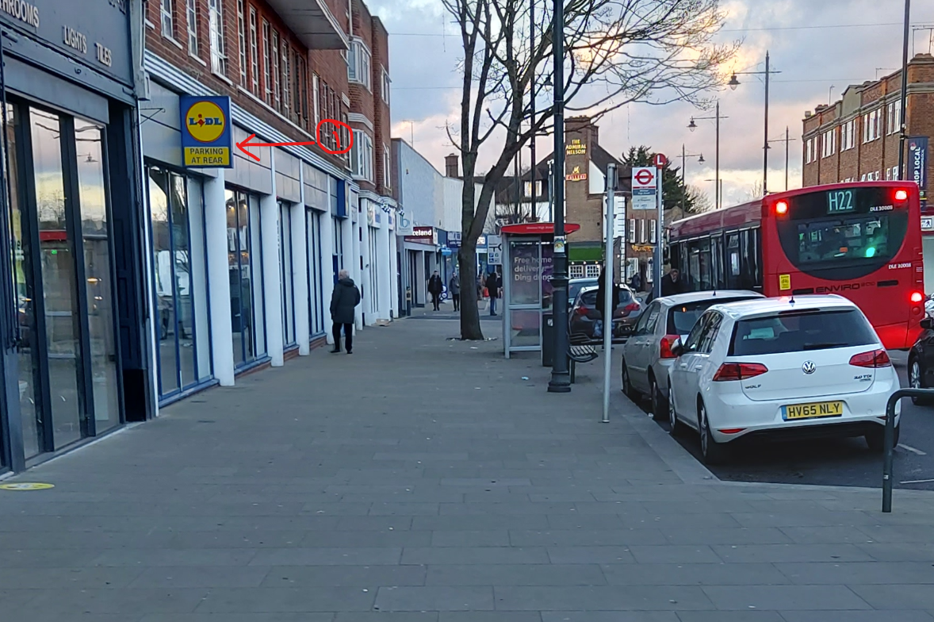

- Exhibit 02 - Next left road entrance following sign with no indication this was a pay and display area
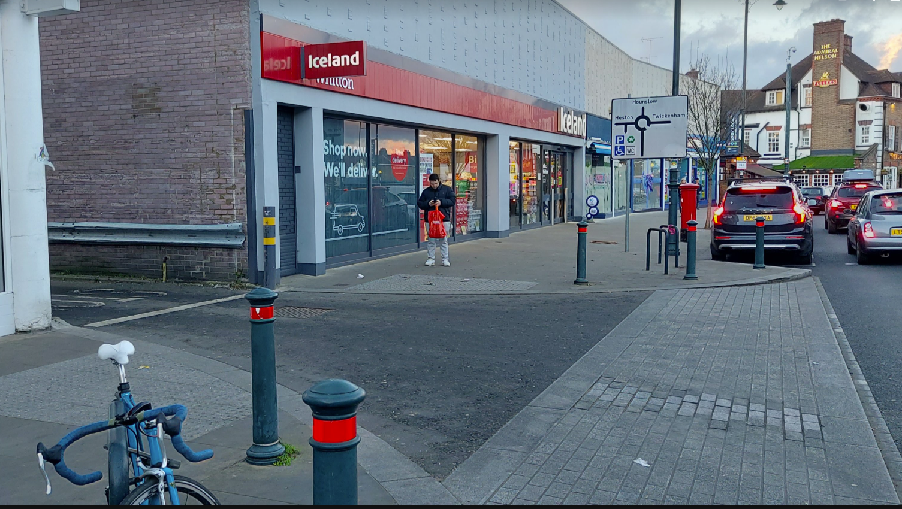

- Exhibit 03 - First sign at the entrance to Car Park: This is at 90 degrees to the drivers view and hidden behind a drain pipe. On the day in question which was dark and raining this was hidden from view by an umbrella held by a couple of people leaving the area.
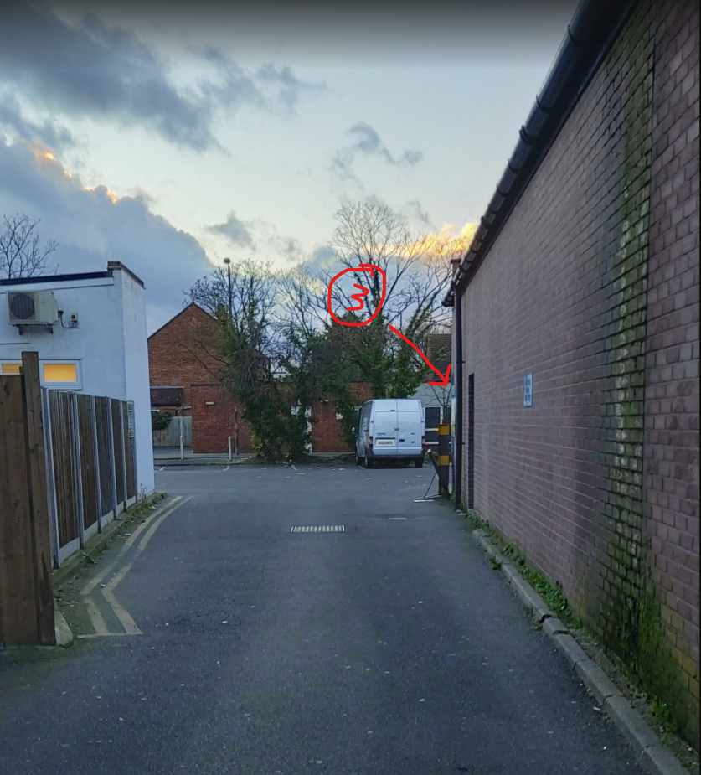

- Exhibit 04 - For reference, this is the same sign face on.

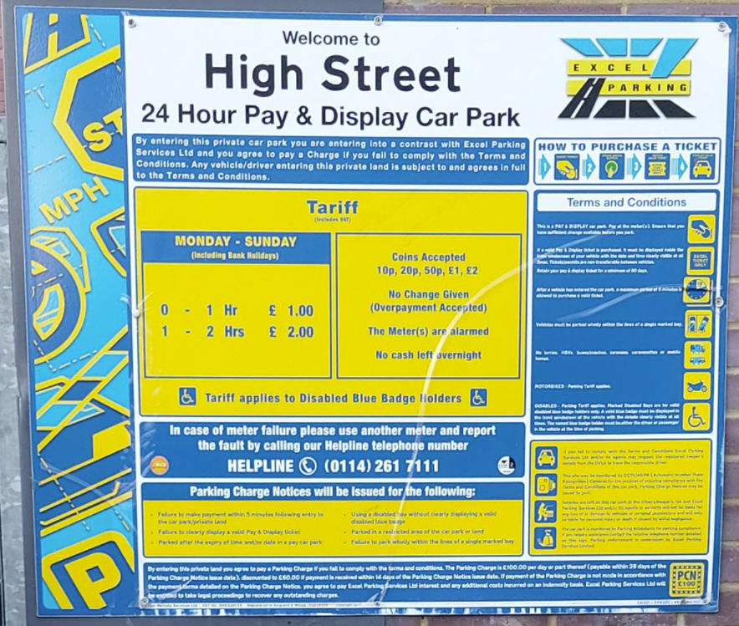

Exhibit 04a Beavis sign for comparison

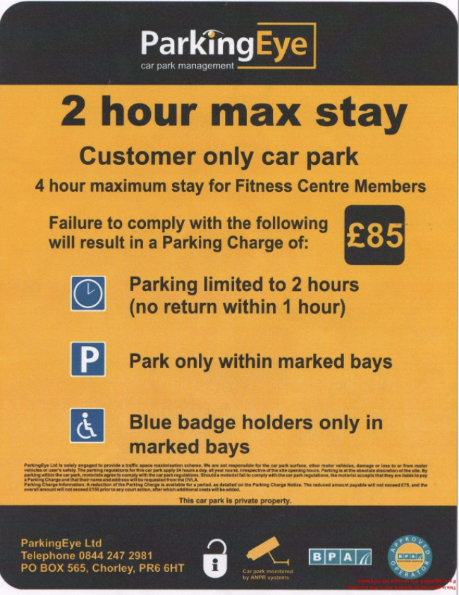

- Exhibit 05 - The only other sign in this area pointed out (5) On the day this was completely hidden from view by a large van. I parked in or to the left of the bay indicated by arrow (5a)

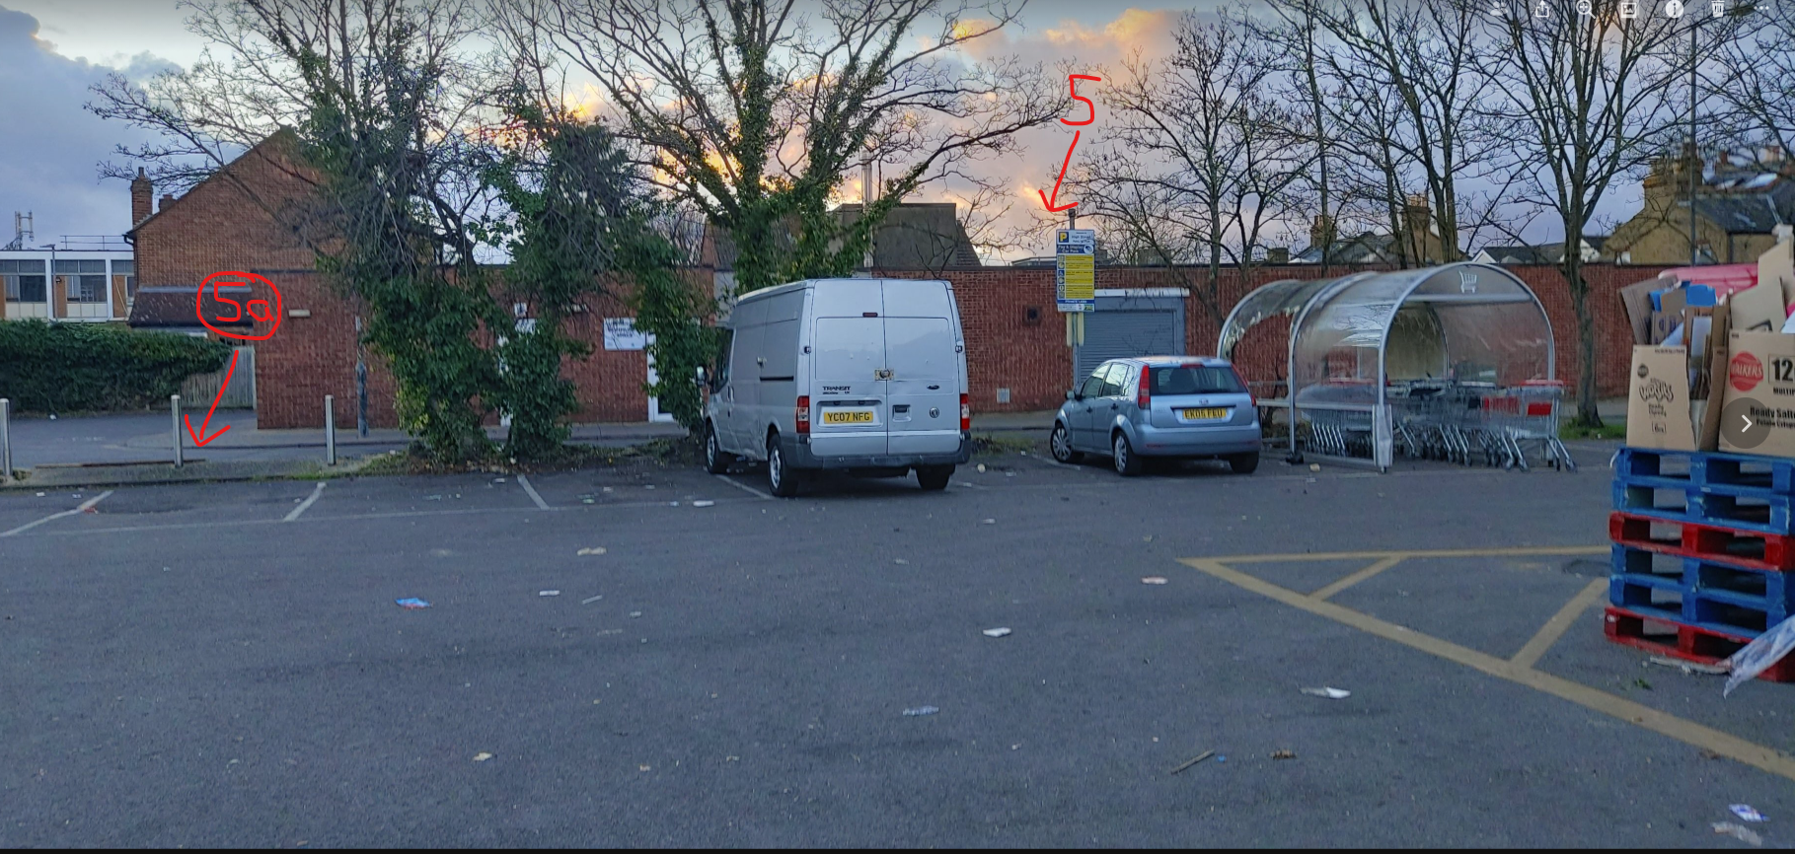

Exhibit - 06: Transcript of Judgement ParkingEye v Beavis, paras 98, 193 and 198 ([2015] UKSC 67)
98. Against this background, it can be seen that the £85 charge had two main objects. One was to manage the efficient use of parking space in the interests of the retail outlets, and of the users of those outlets who wish to find spaces in which to park their cars. This was to be achieved by deterring commuters or other long-stay motorists from occupying parking spaces for long periods or engaging in other inconsiderate parking practices, thereby reducing the space available to other members of the public, in particular the customers of the retail outlets. The other purpose was to provide an income stream to enable ParkingEye to meet the costs of operating the scheme and make a profit from its services, without which those Page 43 services would not be available. These two objectives appear to us to be perfectly reasonable in themselves. Subject to the penalty rule and the Regulations, the imposition of a charge to deter overstayers is a reasonable mode of achieving them. Indeed, once it is resolved to allow up to two hours free parking, it is difficult to see how else those objectives could be achieved.
193. The penalty doctrine is therefore potentially applicable to the present scheme. It is necessary to identify the interests which it serves. They are in my view clear. Mr Beavis obtained an (admittedly revocable) permission to park and, importantly, agreement that if and so far as he took advantage of this it would be free of charge. ParkingEye was able to fulfil its role of providing a traffic management maximisation scheme for BAPF. The scheme met, so far as appears, BAPF’s aim of providing its retail park lessees with spaces in which their customers could park. All three conditions imposed were directed to this aim, and all were on their face reasonable. (The only comment that one might make, is that, although the signs made clear that it was a “Customer only car park”, the Parking Charge of £85 did not apply to this limitation, which might be important in central Chelmsford. The explanation is, no doubt, that, unlike a barrier operated scheme where exit can be made conditional upon showing or using a ticket or bill obtained from a local shop, a camera operated scheme allows no such control.) The scheme gave BAPF through ParkingEye’s weekly payments some income to cover the costs of providing and maintaining the car park. Judging by ParkingEye’s accounts, and unless the Chelmsford car park was out of the ordinary, the scheme also covered ParkingEye’s costs of operation and gave their shareholders a healthy annual profit.
198. The £85 charge for overstaying is certainly set at a level which no ordinary customer (as opposed to someone deliberately overstaying for days) would wish to incur. It has to have, and is intended to have, a deterrent element, as Judge Moloney QC recognised in his careful judgment (para 7.14). Otherwise, a significant number of customers could all too easily decide to overstay, limiting the shopping possibilities of other customers. Turnover of customers is obviously important for a retail park. A scheme which imposed a much smaller charge for short overstaying or operated with fine gradations according to the period of overstay would be likely to be unenforceable and ineffective. It would also not be worth taking customers to Page 88 court for a few pounds. But the scheme is transparent, and the risk which the customer accepts is clear. The fact that, human nature being what it is, some customers under-estimate or over-look the time required or taken for shopping, a break or whatever else they may do, does not make the scheme excessive or unconscionable. The charge has to be and is set at a level which enables the managers to recover the costs of operating the scheme. It is here also set at a level enabling ParkingEye to make a profit. Unless BAPF was itself prepared to pay ParkingEye, which would have meant, in effect, that it was subsidising customers to park on its own site, this was inevitable. If BAPF had attempted itself to operate such a scheme, one may speculate that the charge might even have had to be set at a higher level to cover its costs without profit, since ParkingEye is evidently a specialist in the area.

